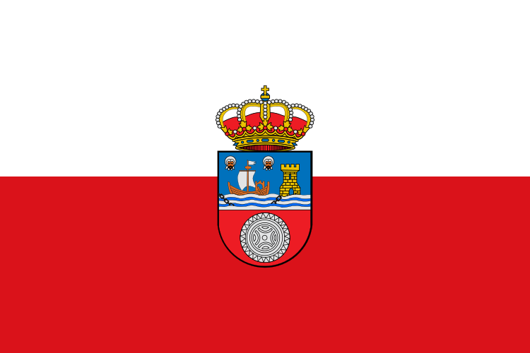

Hello. We are from Spain.
My Autonomus Community is called Cantabria and it has one province. The capital is Santander. The municipality where i live is called Santander.In my Autonomus Community we speak one language.

